RAIN Token Deep-Dive:
High Real-World
Risk Behind a $16B FDV

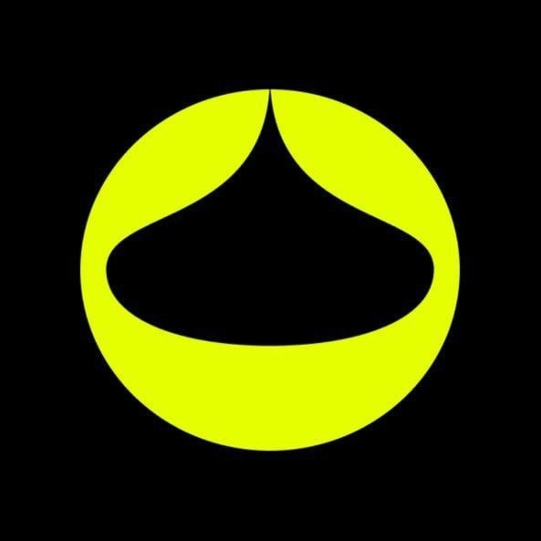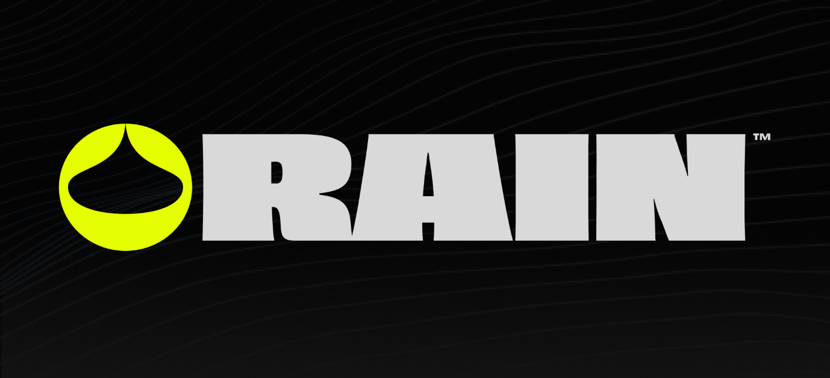
- Token Header:
- Asset Name: RAIN Token (Rain Foundation)
- Category: Decentralized Finance (DeFi)
- Consensus mechanism: Built as an ERC-20 token on the Arbitrum Layer-2 network, leveraging Ethereum’s base-layer security
- Core Utility: Governance incentives and protocol fee mechanics (no native validation or mining rewards).

- Executive Summary:
- RAIN Token is the native asset of Rain protocol, an Arbitrum based decentralized infrastructure layer for AI-driven prediction markets.

- Rain is a decentralized protocol for creating and participating in prediction markets. It operates on the Arbitrum blockchain and allows users to define event outcomes, provide liquidity, and trade positions related to those outcomes. The protocol uses an automated market maker (AMM) mechanism to continuously determine prices based on the proportion of liquidity allocated to each outcome. Market outcomes may be resolved either by the market creator or, in certain public markets, by an Al-based oracle framework (Olympus AI). A dispute mechanism exists which may escalate contested outcomes to human oracles. Rain also supports the creation of incentive-based markets, where economic rewards can be attached to the realization of specific real-world outcomes rather than solely to prediction.

- Protocols and technical standards:
- RAIN is an ERC-20-compliant token deployed on the Arbitrum network, which operates as an Ethereum Layer-2 rollup.
- The project follows widely adopted Ethereum standards, including ERC-20 for fungible tokens and standard bridging interfaces for interoperability with other EVM-compatible networks such as Ethereum, BNB Chain, and Base.
- Smart contracts are written in Solidity and verified on Arbiscan. The token contract is non-upgradeable, and the protocol architecture adheres to established DeFi security and interoperability best practices.

- Potential Risks:
Price manipulation and Insider control:
- RAIN’s market activity shows signs of on-chain price manipulation, and alleged that addresses tied to the deployer used Uniswap V3 liquidity pools while routing spot transfers through the Gems hot wallet.
- The RAIN token linked to Rain Protocol is under scrutiny after claims that 81 wallets hold nearly all of its supply, raising concerns about price manipulation and insider control.
- The token's high wallet concentration and liquidity setup creates transparency and risks for retail investors.
Wallet concentration:
- 1 High concentration (There are 10 holders who own at least 1% of total supply)
- Market Cap of Top 5 holders: 79.04% | Top 10 holders: 88.34%

Smart Contract Risk:
Repository: https://github.com/rain1-labs/rain-token
Name: RAIN
Decimals: 18
Token Contract: 0x25118290e6A5f4139381D072181157035864099d

As per the audits done by Halborn and Hacken there were no Critical or high-severity vulnerabilities were identified.
- Found Medium level (PriceFeed Integration safeguards) and 6 observation level findings which are resolved and mitigated prior to deployment.

Audit Summary:
- 7 Total Findings 5 Resolved
- 1 Accepted 1 Mitigated
Audit Findings:
ID | Title | Severity | Status
F-2025-12213 | PriceFeed Integration Lacks Safeguards Compromising Minting Policy | Medium | Mitigated
F-2025-12241 | Misaligned USD Cap Calculation Due to USDT Peg Assumption | Observation | Fixed
F-2025-12222 | Redundant State Initialization | Observation | Fixed
F-2025-12214 | Duplicated Token Name and Symbol Can Lead to Confusion | Observation | Accepted
F-2025-12211 | Missing Visibility on totalInflationMinted Prevents Tracking of Total Minted Inflation | Observation | Fixed
F-2025-12210 | Missing Two-Step Ownership Transfer Increases Risk of Permanent Owner Loss | Observation | Fixed
F-2025-12209 | Floating Pragma | Observation | Fixed

Oracle Risk:
- The project depends on a single oracle price feed to determine mint amounts.
- This reliance introduces risks of inaccurate issuance or denial of service if the feed is manipulated, malfunctioning, or unavailable, directly affecting the system’s integrity.
- Allowing the admin to set oracle addresses without constraints or verification mechanisms introduces the risk of incorrect or malicious oracle selection, affecting the accuracy of data and potentially leading to financial losses.
Centralization Risk:
- The token ecosystem grants a single entity the authority to implement upgrades or changes.
- This centralization of power risks unilateral decisions that may not align with the community or stakeholders' interests, undermining trust and security.
Contract Risk:
- The contract suite allows for immediate upgrades without a mandatory review or waiting period, increasing the risk of rapid deployment of malicious or flawed code, potentially compromising the system's integrity and user assets.
General Risk:
- The value of RAIN may fluctuate significantly based on market conditions, protocol adoption, or external events affecting the DeFi sector.
Network dependency:
- Operation relies on the Arbitrum Layer-2 and Ethereum base layer; congestion, outages, or protocol changes on either network could disrupt service.

- MicoStrategy Approach:
- DeFi protocols exist in a legal grey area because regulators find it hard to subpoena a DAO. However, because Enlivex has effectively pulled a "MicroStrategy" by converting its treasury into RAIN tokens, the regulatory shield of decentralization is gone.
- The SEC can heavily pressure Enlivex’s board to force disclosures regarding the true identity of the RAIN deployers, turning an on-chain protocol into a corporate compliance headache.
- Market Abuse Regulation (MAR) scrutiny:

- Supply Illegitimacy Scrutiny:
- RAIN can no longer hide behind the excuse of "DeFi anonymity." Because its token supply is highly centralized and has crossed over into a Nasdaq-listed corporate treasury, it has painted a massive bullseye on itself.
- If the team does not aggressively transparentize the lockup schedules, prove the independence of those 81+ wallets, and foster organic volume, regulators are highly likely to treat the structure as an intentionally manipulated, unregistered financial instrument.
- Links to Failed Crypto Projects:
- wallets tied to the RAIN team share funding trails with the Data Ownership Protocol (DOP) and TOMI ecosystems via the Gems hot wallet and several centralized exchange deposit addresses, which suggests an overlap between the projects.
- Two “dust” transactions were sent to the same address on Oct. 14, 2025. A wallet linked to the RAIN deployer sent a small transfer to the address at 3:31:47 p.m. UTC, while a wallet associated with the TOMI team multisig and a centralized exchange deposit address sent another dust transaction to that same destination 36 seconds earlier. The recipient wallet later received funds from another address that had previously been funded by a DOP multisig.
- DefiLlama data showing RAIN has $27.2 million locked on Arbitrum, but the entire amount is held in its own illiquid token and that the protocol generates only about $1 million in annual fees. TOMI, DOP and Sirin Labs projects are all linked to controversial Israeli entrepreneur Moshe Hogeg, who was arrested in 2021 and later faced police allegations over a $290 million crypto fraud scheme.

- The Bottom Line:
- RAIN has achieved the liquidity and valuation of a blue-chip crypto asset, but its legal infrastructure is still built like a wild-west DeFi project. As its exposure to traditional finance (via NASDAQ and Gate.io listings) deepens, the token will inevitably face a regulatory reality check. Watch whether the team introduces aggressive geographic blocking and wallet transparency; if they don't, a regulatory clampdown is a matter of "when," not "if."

Key Metrics:
FDV vs. Real TVL | Fully Diluted Valuation (~$16B) vs. Actual TVL (~$27M). | Massive red flag. A massive valuation supported by tiny, illiquid actual deposits means the price is heavily propped up by narrative rather than utility.
Wallet Concentration | Tracing the top 80–100 wallets (mostly linked to deployers/Gems hot wallets). | If a few insider wallets control the vast majority of the circulating or locked tokens, retail holders are entirely at the mercy of their selling whims.
Organic vs. Wash Volume | The ratio of daily exchange trading volume to actual prediction market fees. | Reports show the protocol generates very low real annual fees. High exchange volume with low product fees usually points to artificial market making.
Treasury Lock & Unlock Schedule | When the Rain Foundation or Enlivex can liquidate their massive multi-billion token holdings. | An avalanche of token unlocks over the next few years will create constant sell pressure unless actual usage scales exponentially.
- Conclusion:
- The RAIN token sits at a fascinating, yet incredibly perilous, crossroads in Web3 history. By securing a multi-billion dollar fully diluted valuation and successfully anchoring itself to a NASDAQ-listed corporate treasury, it has achieved a level of institutional exposure most DeFi projects can only dream of.
- However, public ledgers do not lie. The on-chain footprints analyzed in this report reveal a project still operating under the "Wild West" rules of early DeFi: extreme wallet concentration, opaque funding trails overlapping with controversial past ecosystems, and an severe disconnect between a $16 billion valuation and just $27 million in organic utility.
- As traditional financial scrutiny and protocols like the Market Abuse Regulation (MAR) tighten their grip on the crypto markets, RAIN can no longer hide behind the traditional shield of decentralized anonymity. If the team does not aggressively implement strict geographic blocking, transparentize their lockup schedules, and foster legitimate, product-driven volume, a severe regulatory or liquidity reality-check is not a matter of if—it is strictly a matter of when. For retail investors, navigating this ecosystem demands extreme caution.

⚠️ Disclaimer & Disclosure
1. Not Financial or Legal Advice: The following article is for informational, educational, and research purposes only. It does not constitute financial, investment, legal, or tax advice. Do not use this analysis as the basis for buying, selling, or trading any equity, digital asset, or cryptocurrency.
2. On-Chain Data & Forensic Interpretation: All wallet linkages, transaction hashes, timestamps, and smart contract data presented in this report are sourced exclusively from immutable, publicly accessible blockchain ledgers and verified third-party blockchain analytics tools (e.g., DefiLlama, Etherscan, Arbiscan). While the data itself is factual, on-chain relationships, funding clusters, and transactional associations represent behavioral patterns and analytical interpretations rather than absolute statements of intent, corporate structural reality, or legal ownership.
3. Presumption of Innocence: Any mentions of past investigations, arrests, or historical legal proceedings involving third parties (including but not limited to Moshe Hogeg or previous entities like TOMI and DOP) are pulled directly from documented public media and legal reporting. No assertions of current unlawful behavior or active fraudulent coordination regarding the Rain Protocol or Enlivex Ltd. are being made or implied. All entities and individuals named are presumed innocent of any unproven allegations.
4. Independence Disclosure: The author of this article is an independent analyst and maintains a completely neutral position. The author holds no financial exposure to RAIN tokens, Enlivex Ltd. equity (NASDAQ: ENLV), or any associated protocols mentioned herein, and has received no compensation for publishing this research.

